---------------------------------------  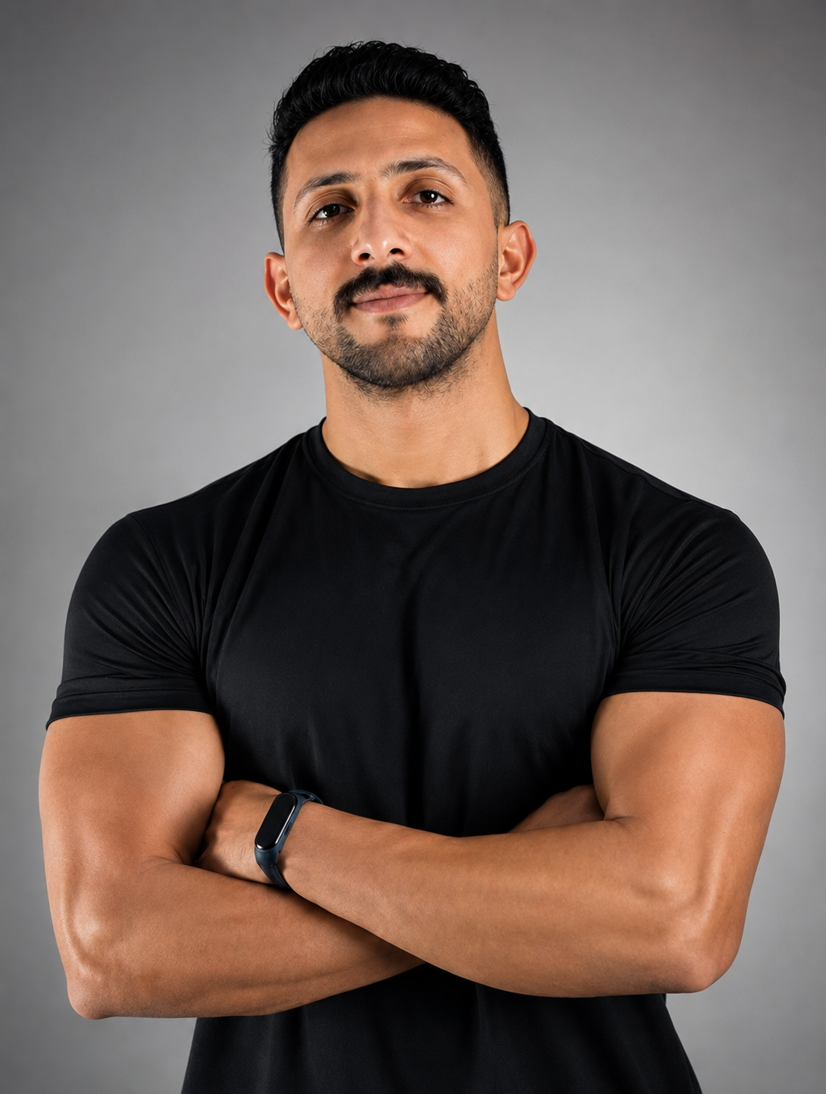  CONTACT INFO  +966504224831  amrh34263@gmail.com  Dec 1995  EDUCATION  Bachelor of Physical Education  Helwan University | 2017  Overall: Very Good  Master Researcher in HIIT & Nutrition  CERTIFICATIONS  • ISSA CFT  • Injury Rehabilitation  • First Aid  • Rescue Course  • TOEFL ITP  SKILLS  ■ Strength & Conditioning  ■ Body Transformation  ■ HIIT  ■ Sports Rehab  ■ Nutrition  ■ Leadership  ■ Mobility  ■ Functional Training  ACHIEVEMENTS  🏆 Top Trainer KSA - Q1  🏆 Top Trainer KSA - Q2  🏆 Promoted to Senior PT  🏆 10+ Years Experience | AMR HUSSIEN ABDELAZIM  / Senior Personal Trainer  / Sports Rehabilitation Specialist  / Performance Coach  PROFESSIONAL PROFILE  Performance-driven fitness professional with over 10 years of experience helping clients transform their health through evidence-based coaching, rehabilitation, and high-performance training.  PROFESSIONAL EXPERIENCE  Senior Personal Trainer | Enhance Fitness  Feb 2026 – Present  • Promoted to Senior Personal Trainer.  • Recognized as Top Trainer in Saudi Arabia for Q1 & Q2.  • Deliver premium coaching & transformation programs.  Physiotherapist | We Care Centre  2024 – Present  • Lead rehabilitation and return-to-sport programs.  Personal Trainer & Rehab Specialist | Physio Slim  2021 – Present  • Designed personalized fitness and rehabilitation plans.  Lecturer | Military Academy  2017 – 2020  • Delivered exercise science and nutrition education.  Swimming Coach | Wadi Degla  2013 – 2017  • Developed athletes across multiple age groups.  COACHING PHILOSOPHY  Helping people become stronger, healthier, and more resilient through disciplined, science-backed coaching and sustainable lifestyle transformation.

